A Software Process Framework is a structured set of activities, methods, and practices that provides a foundation for building and managing software development processes. It defines what needs to be done during the software development lifecycle (SDLC) without prescribing exact details of how to do it.
✅ Key Points:
- It is a skeleton or blueprint for a software process.
- Ensures consistency, quality, and efficiency across projects.
- Each framework includes activities, tasks, and work products (artifacts).

Main Activities in a Generic Software Process Framework (as per Pressman):
- Communication
  - Understanding customer needs.
  - Activities: Requirements gathering, stakeholder meetings.
- Planning
  - Defining project plan, schedule, resources, and risk analysis.
- Modeling
  - Designing the system (architecture, data, UI).
- Construction
  - Coding and testing the software.
- Deployment
  - Delivering the product and providing support.

✅ Popular Software Process Frameworks
- Waterfall Model (sequential phases)
- Incremental Model (build in increments)
- Spiral Model (risk-driven)
- Agile Frameworks (Scrum, Kanban)

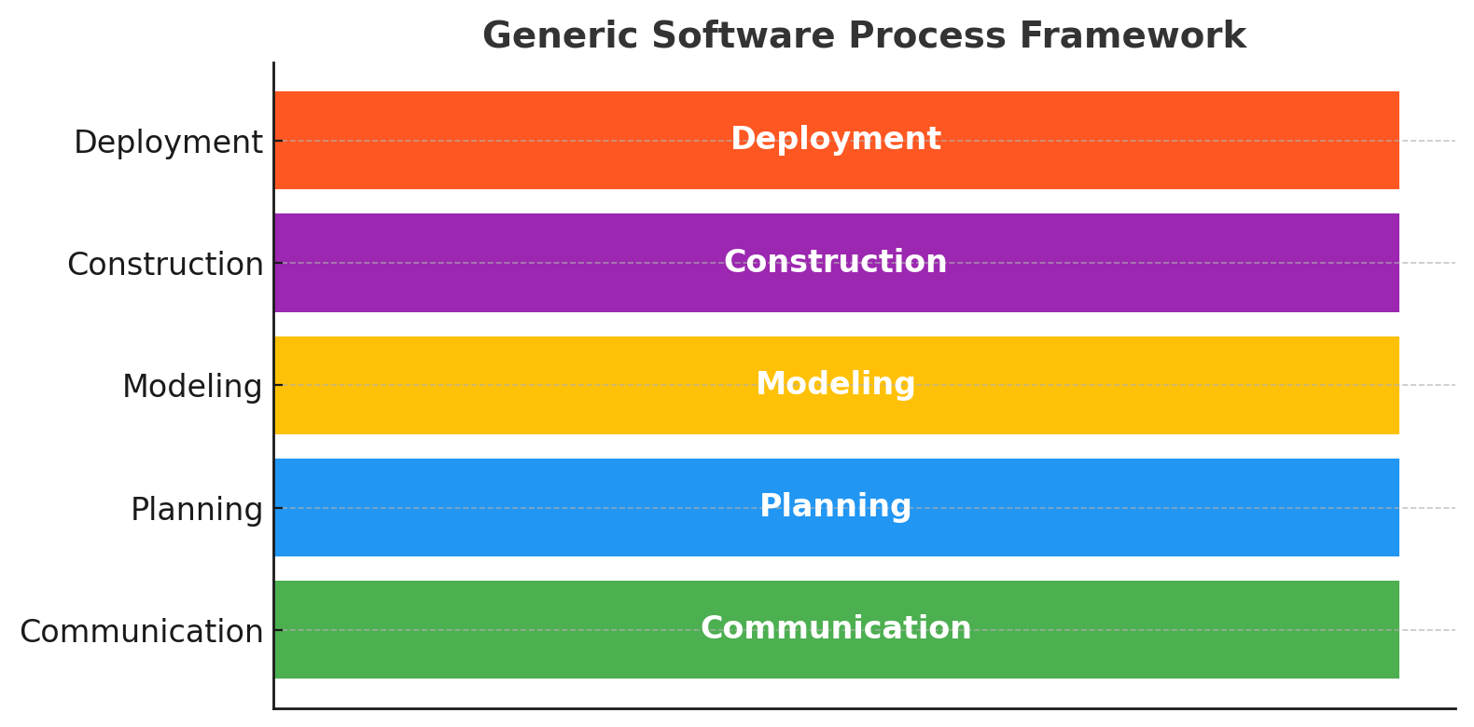
Here’s a simple diagram showing the Generic Software Process Framework with its five main activities: Communication → Planning → Modeling → Construction → Deployment.

